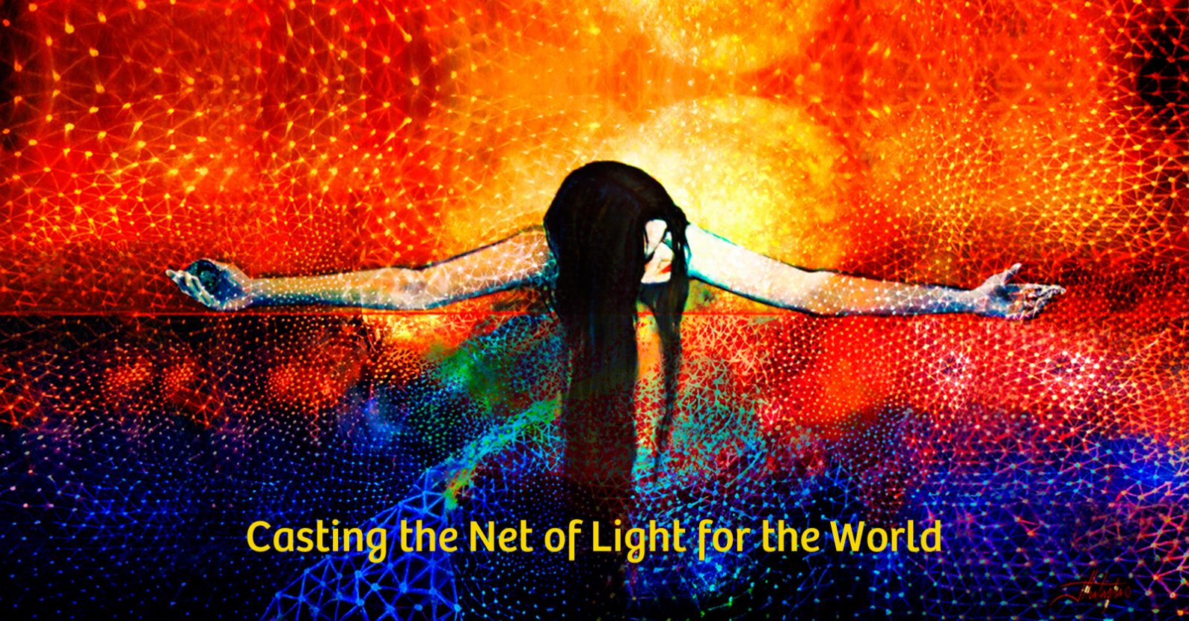

Is your heart yearning for something greater than yourself, something that speaks to your deepest purpose here on earth at this time?

Hopi prophecy states, "When the Wisdom of the Grandmothers is heard,
the world will Heal,” and at last the Grandmothers have come.

We are women and men seeking a personal connection with the Divine—one free from rules and formal religion. We want a sense of community, more joy in our lives, and wish to be of service during this time of radical change on our planet. The Great Council of the Grandmothers first appeared in 1996 as Sharon McErlane walked her dog. "The world is in grave danger," they said, "and we will not allow its destruction. For too long Yang or masculine energy, has dominated life on earth, causing feminine energy to become deficient and weak. We have come to restore Yin to full beauty/power and return the world to balance. We will do this work primarily through individual women and we are calling you to this work."
Today over 200 groups meet around the world to spread the Grandmothers' message and teach people how to work with the Net of Light. "The Net of Light," the Grandmothers say, "supports everything in the Universe and will hold the earth steady during the times of change that are upon you now. Work with the radiant Net," they urge, "to support life.”

Join us (once/twice) a month to study A Call to Power: the Grandmothers Speak.

For more information or to sign up,
please contact : Name
Phone
Email
Street Address

